**RAJALAKSHMI ENGINEERING COLLEGE**

**RAJALAKSHMI NAGAR, THANDALAM – 602 105**



|  |
| --- |
| **CS23A34**  **USER INTERFACE AND DESIGN LAB** |
| **Laboratory Observation Notebook** |

# Name : Sanjay kumar.K

# Year/Branch/Section : II/CSE/C

# Register No. : 230701289

# Semester : IV Academic Year: 2024-25

**Ex. No.: 8.B**

**Register No.: 230701289**   **Name: Sanjay kumar.K**

**Create storyboards to represent the user flow for a mobile app (e.g.,**

**food delivery app) using OpenBoard**

**AIM**:

To map out the user flow for a mobile app (e.g., a food delivery app), storyboards will be designed using OpenBoard.

**PROCEDURE:**

**Tool Link: https://openboard.ch/download.en.html**

**Step 1: Define the User Flow**

1. **Identify Key Screens**:
   1. List the main screens your app will have (e.g., Home, Menu, Cart, Checkout, Order Confirmation).
2. **Map the User Journey**:
   1. Understand the typical user journey through these screens (e.g., browsing menu, l2adding items to cart, checking out).

**Step 2: Create Storyboards Using OpenBoard**

1. **Install OpenBoard**:

○ Download and install OpenBoard from the official website.

1. **Create a New Document**:

○ Open OpenBoard and create a new document.

1. **Add Frames for Each Screen**:

○ Use the drawing tools to create frames representing each key screen of your app.

1. **Sketch Each Screen**:
   1. Use the pen or shape tools to draw basic elements for each screen.

○ Focus on major UI components like buttons, text fields, and icons.

1. **Organize the Flow**:
   1. Arrange the frames in a sequence that represents the user journey.

○ Use arrows or lines to show navigation paths between screens.

**Example Screens for Food Delivery App**

1. **Home Screen**:
   1. Search bar for finding restaurants

○ Categories for different cuisines

1. **Menu Screen**:
   1. List of food items with images, names, and prices

○ Add to Cart buttons

1. **Cart Screen**:
   1. Items added to the cart with quantity and total price

○ Checkout button

1. **Checkout Screen**:
   1. Delivery address form

○ Payment options ○ Place Order button

1. **Order Confirmation Screen**:
   1. Order summary

○ Estimated delivery time

**OUTPUT:**

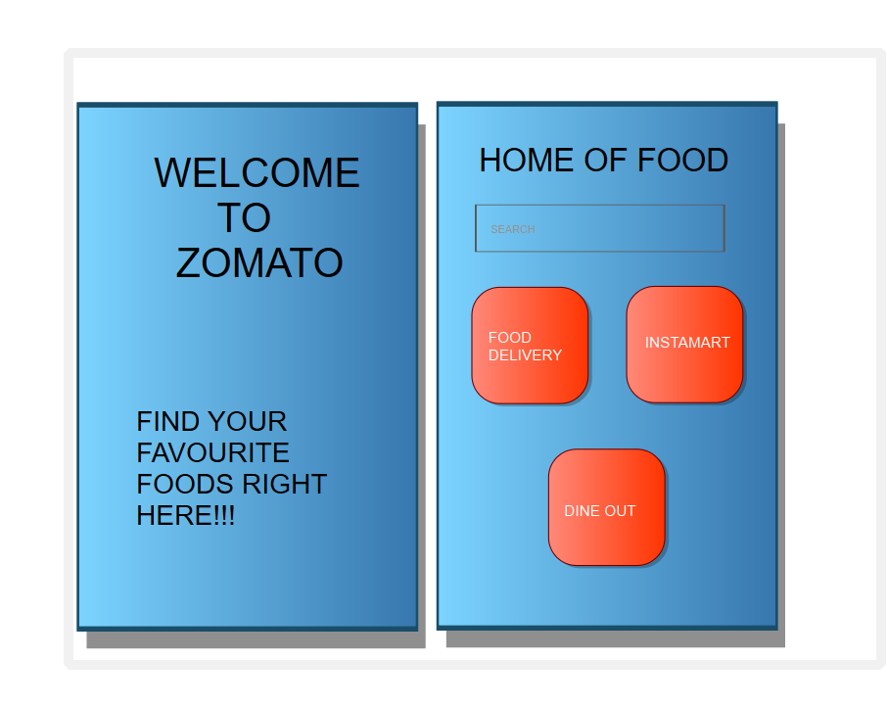

**RESULT:**

The user flow for a mobile app (e.g., a food delivery app), storyboards has beeen designed using OpenBoard.